BalkanMed Programme
Launching Event & Info Day - 1st Call for Project Proposals

10, March , 2016

Venue: Best Western Hotel Expo
149 Tsarigradsko Shosse, Blvd.
Sofia, Bulgaria

Preliminary Agenda
09:30 – 10:00 | Registration and Welcome Coffee
10:00 – 10:15 | Welcome and introduction  - by representative of BalkanMed Programme National Authority - Ministry of Regional Development and Public Works  - by representative of BalkanMed Programme Managing Authority of European Territorial Cooperation Programmes - Greece
10:15 – 10:30 | The Transnational Cooperation Programme Interreg V-B ‘Balkan-Mediterranean’ 2014-2020: Priorities, objectives & implementing provisions  representative of BalkanMed Programme National Authority/National Contact Point “Territorial Cooperation Management” DG
10:30 – 11:30 | 1st Call for Project Proposals: Presentation of the Call, rules & procedures  Application form: Instructions on how to fill it in  Project evaluation: Criteria and two-step procedure  representative of BalkanMed Programme Managing Authority of European Territorial Cooperation Programmes - Greece
11-30 – 12:10 | Partner Search Café – Coffee Break
12:10 – 14:00 | Eligibility of expenditure: applicable rules & common mistakes  Project communication and dissemination  Contracting, monitoring, control, reimbursement and financial flows  Tools for partner Search  representative of BalkanMed Programme Managing Authority of European Territorial Cooperation Programmes - Greece  First Level Control, National Co-financing, common mistakes and lessons learned  representative of “Territorial Cooperation Management” DG, BG National Contact Point  Questions and Answers session  - representative of BalkanMed Programme National Authority “Territorial Cooperation Management” DG, Ministry of Regional Development and Public Works  - by representative of BalkanMed Programme Managing Authority of European Territorial Cooperation Programmes - Greece

How to register
Please, register maximum 2 participants per organisation for event by filling in the online registration form available at the following link.
Venue: Best Western Hotel Expo www.hotelexposofia.com
149 Tsarigradsko Shosse, Blvd.

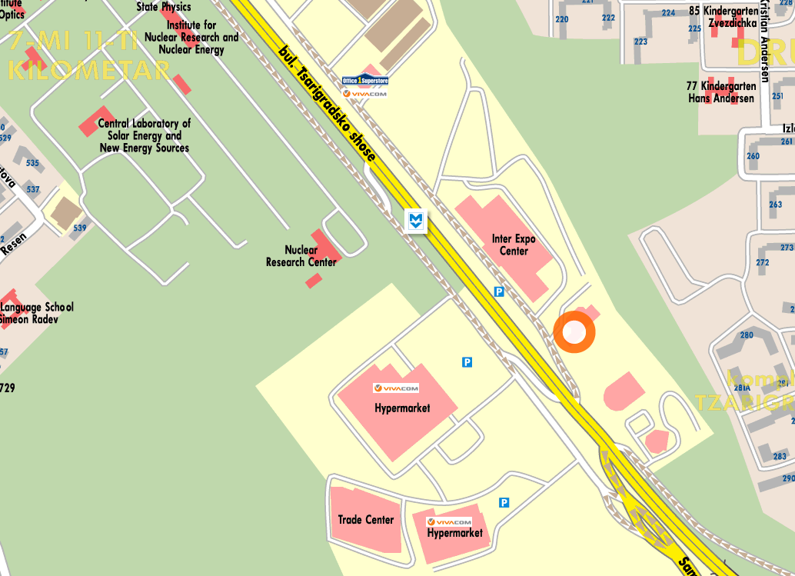
Best Western Expo Hotel Sofia is within several minutes from the majority key business points and touristic locations: visitors can reach Sofia's International Airport with direct Metro connection in only 2 minutes, and the city center within 12. “Tsarigradsko shousse” Metro Station is located outside the hotel.

