INTERREG EUROPE Information Day
19 May 2015
Venue: Best Western Hotel Expo
149 Tsarigradsko Shosse, Blvd.
Sofia, Bulgaria

Preliminary Agenda
9:00 - 9:30 | Registration
9:30 – 09:40 | Welcome and introduction  by representative of “Territorial Cooperation Management” DG, Ministry of Regional Development and Public Works
9:40 – 11:00 | Introduction of INTERREG EUROPE Programme  From INTERREG IVC to INTERREG EUROPE (Benoît DALBERT and Ilaria PIAZZA - representatives of INTERREG IVC/ INTERREG EUROPE JS)  - understanding new features of projects & platforms  - focus on SFs and work with MAs and policy responsible organizations  - regional dimension of the cooperation (stakeholder groups, action plans)  - nature/ role of project partners  Questions and Answers
11:00 – 11:20 | Coffee Break
11:20 -12:30 | Support for projects  Presentation of INTERREG EUROPE applicant support tools: project idea database, partner search tools/ events, programme manual, application form, Letter of support from the relevant policy responsible organization (Ilaria PIAZZA - representative of INTERREG IVC/ INTERREG EUROPE JS)  NCP support: support letter, national eligibility requirements, FLC system, partner search assistance (Irina RANGELOVA - representative of “Territorial Cooperation Management” DG, BG National Contact Point)
12:30 -13:00 | Questions and Answers
14:00 – 18:00 | Individual consultations (by appointment – 45 min/ project)  (Benoît DALBERT and Ilaria PIAZZA - representatives of INTERREG IVC/ INTERREG EUROPE JS)
18:00 | End of session

How to register
Please, register for event by filling in the online registration form available at the following link http://goo.gl/forms/E0qisjk3RJ as soon as possible, the latest by 13th May 2015.
Feedback on your project idea - Individual consultation
If you decide to request a feedback on your project idea from the INTERREG EUROPE Joint Secretariat (JS):
1. Register to the event.
2. Complete "Project idea feedback form" and send it directly to JS info@interregeurope.eu with AssistanceF in the subject line with copy (CC) to G.Ivanova@mrrb.government.bg.
3. Book a time slot for a 45-minute consultation, directly at the programme website.
If the project idea is relevant to the programme, you will get a confirmation email by JS with the booking details.
In case you request a feedback on your project idea, please register the latest by 5 May 2015.

Venue: Best Western Hotel Expo www.hotelexposofia.com
149 Tsarigradsko Shosse, Blvd.

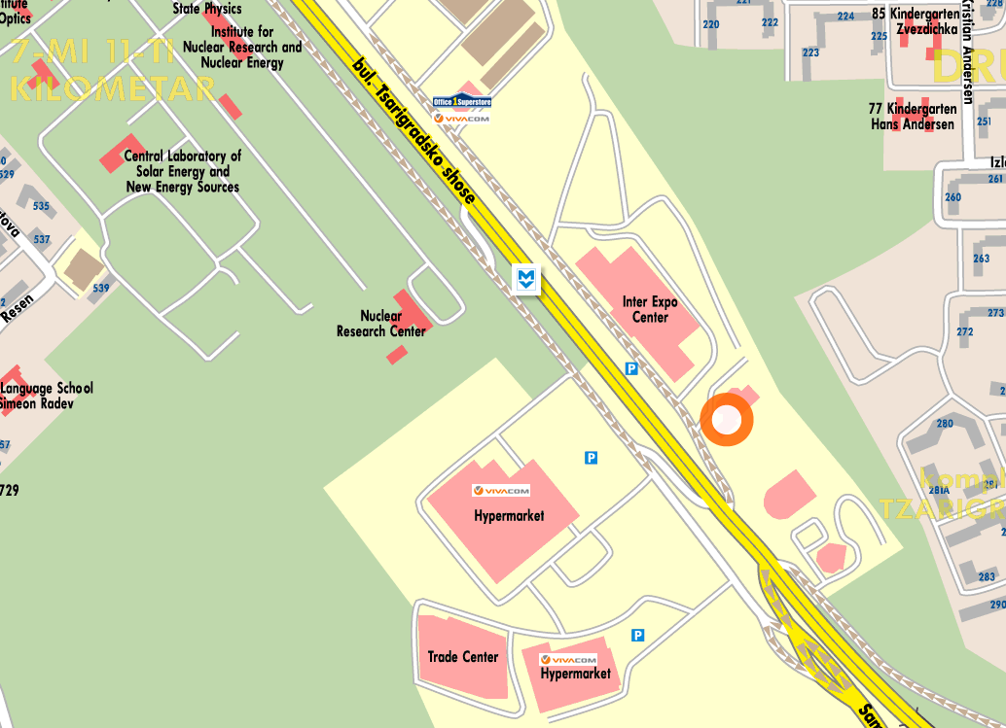

Best Western Expo Hotel Sofia is within several minutes from the majority key business points and touristic locations: visitors can reach Sofia's International Airport with direct Metro connection in only 2 minutes, and the city center within 12. “Tsarigradsko shousse” Metro Station is located outside the hotel.

