Interreg Europe Information Day
Venue: Best Western Hotel Expo
149 Tsarigradsko Shose, Blvd.
Sofia, Bulgaria

Agenda
16 February 2017
9:00 - 9:30 | Registration
9:30 – 09:45 | Welcome and introduction  by representative of “Territorial Cooperation Management” DG, Ministry of Regional Development and Public Works
9:45 – 10:30  10:15 – 10:30 | Interreg Europe  Benoît DALBERT, Marie GRARDEL - representatives of Interreg Europe JS  - Key features of Interreg Europe  - Programme main features & rationale (incl. focus on Structural Funds, role of stakeholders and elaboration of action plans)  - Eligibility of organisations and co-financing  - Programme’s actions (projects/ platforms) and finances  - Results of the 1st and 2nd call for proposals  Questions and Answers
10:30 – 11:00 | Coffee break
11:00 – 12:15  12:15 – 12:45 | Presentation of 3rd call for proposals and support for applicants  Benoît DALBERT, Marie GRARDEL - representatives of Interreg Europe JS  Irina RANGELOVA - representative of “Territorial Cooperation Management” DG, BG national Point of Contact  - Key features of the 3rd call for proposals (JS)  - Terms of reference  - Programme’s templates  - Points of attention for the 3rd call (JS)  - Eligibility: most common mistakes to avoid  - Assessment: major points to keep in mind  - Support for applicants (JS & PoC)  - JS support tools: project idea database, partner search tools, events  - PoC support: national eligibility requirements and co-financing , FLC system, partner search assistance  Questions and answers
12:45 | End of session
14:00 – 18:00 | Individual consultations (by appointment – 45 min/ project)  Benoît DALBERT, Marie GRARDEL - representatives of Interreg Europe JS  A limited number of individual consultations on project idea will take place during this event. To request an individual consultation, the participant first needs to register in the INTERREG EUROPE community at http://www.interregeurope.eu/account/registration/, publish a project ides and request feedback at the Information Day by 9 February 2017.  A consultation will take place only after approval by the Joint secretariat. Before submitting an idea for feedback please benefit from our self-assessment tool available at http://www.interregeurope.eu/self-assessment

How to register
Please, register for event by filling in the online registration form available at the following link https://goo.gl/forms/1xjvu1bq0W1qgupO2 as soon as possible. There is a limited capacity for attendance, so you will be signed in for participation on the first come, first served principle, the latest by 13 February 2017.
Venue:
Best Western Hotel Expo, 149 Tsarigradsko Shose, Blvd.
www.hotelexposofia.com
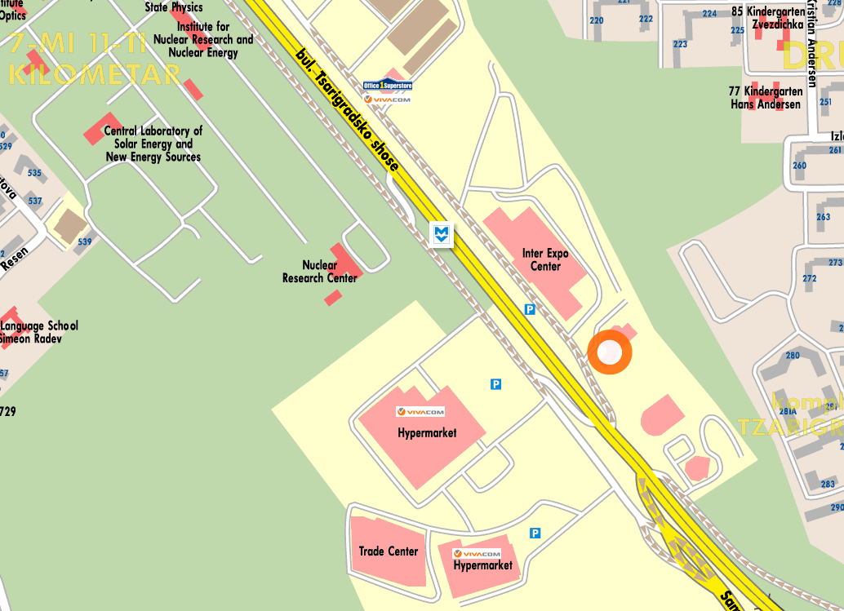
Best Western Expo Hotel Sofia is within several minutes from the majority key business points and touristic locations: visitors can reach Sofia's International Airport with direct Metro connection in only 2 minutes, and the city center within 12 minutes. “Tsarigradsko shousse” Metro Station is located outside the hotel.

